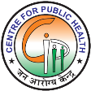

***Monitoring District Mental Health Program in Karnataka***

***Email: dmhp.karnataka@gmail.com***

***Mob: 9686248282***

***A Joint Public Health Initiative of National Health Mission, Government of Karnataka with NIMHANS in collaboration with International Institute of Information Technology - Bengaluru***

**USER GUIDELINES**

**Beta Version 1.3**

***The present software version is available as an online version only; hence internet should be on when data entry is being done.***

***This revised test version of the software will require collation of data at the Taluka level.***

***Please note data from CHCs and PHCs have to be collected and collated at the Taluka level and then entered into the software.***

***At the district level patent care data should not be entered; the taluka level data will get collated automatically at the district level.***

***The District headquarters Taluka should all details related to patient care as their own Taluka data.***

**Please refer to the guidelines given below before you starting using the software**

**A] Logging in to the software :**

**Step 1:**

Use link [**http://indianmhs.nimhans.ac.in:90/dmhp**](http://indianmhs.nimhans.ac.in:90/dmhp) to land on the login page

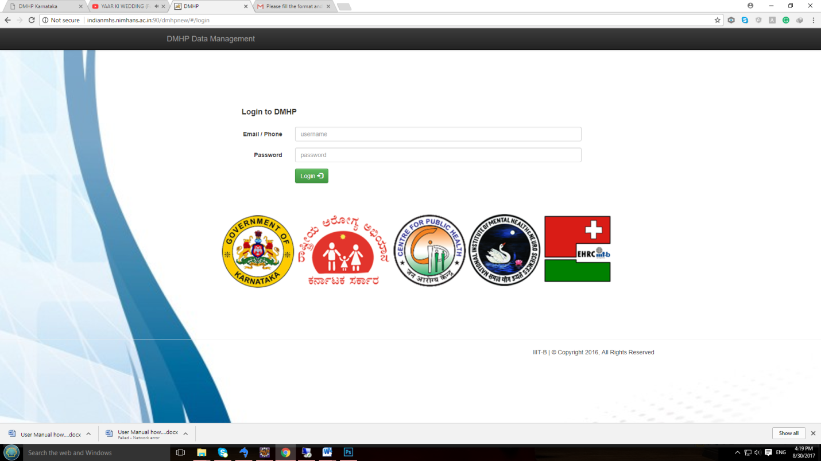

**Step2:**

Enter valid username & password to login; The login and password are case sensitive

***See provided excel sheet for details; Login id and password is valid this only for this version of the software***

Username: xxxx@gmail.com Password: xxxx

.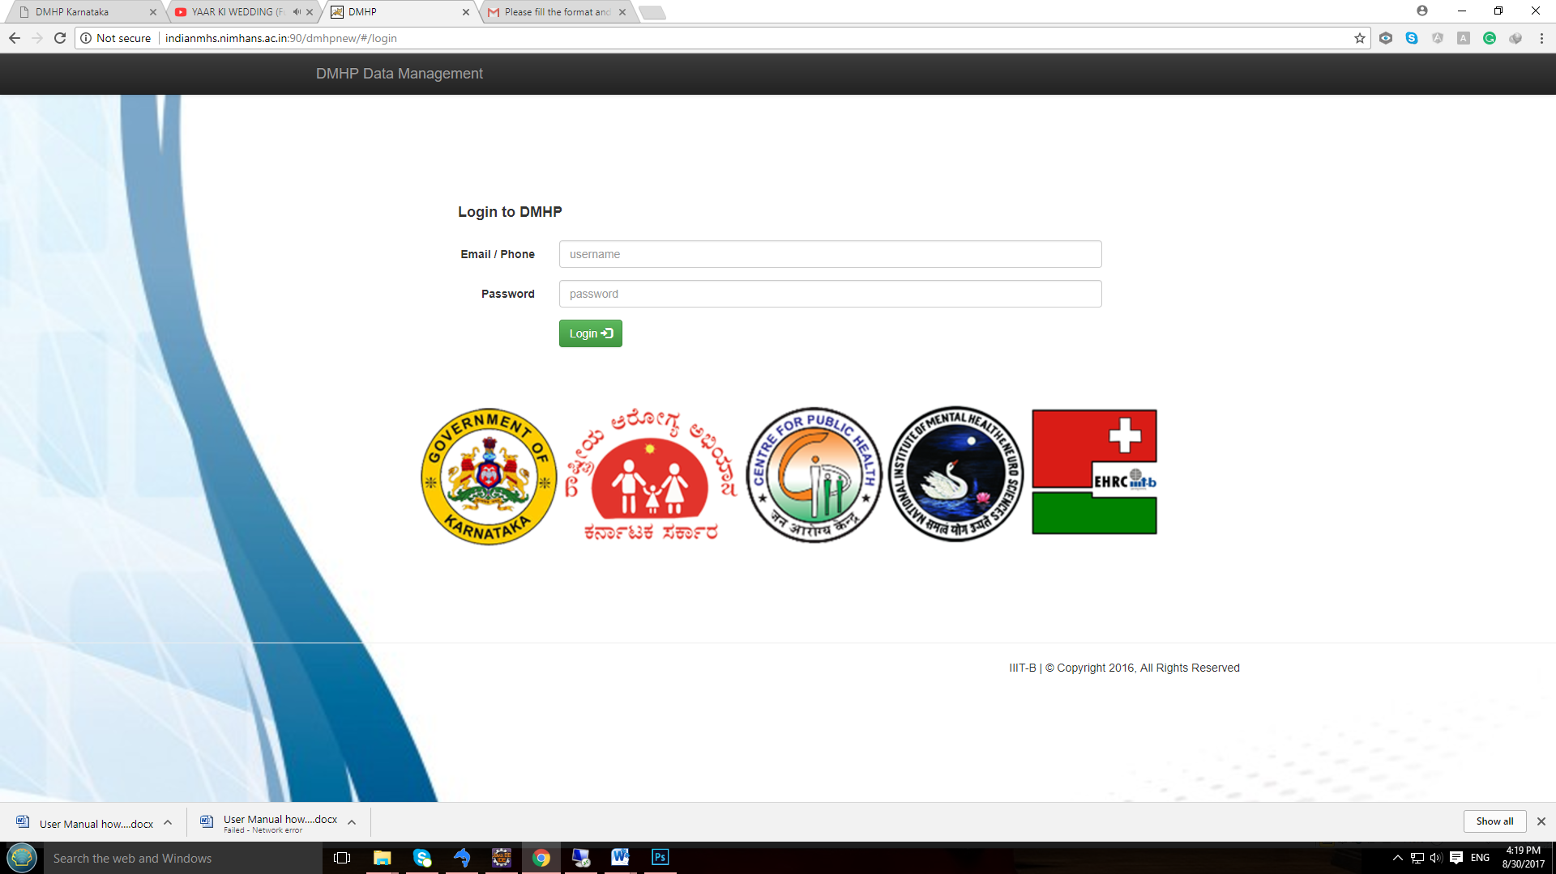

**B] Taluka Level Login :**

* ***For Login follow step 1 & step 2***

1. After logging in, based on Login credentials, the Facility type, District and Name of the PHC / CHC and Taluka will get populated automatically and this is by default.
2. Note that the date of reporting will be by default the Server date, month and year
3. Edit / Modify “***Name of the Administrative MO***” and “***Name of the report submitting official***”

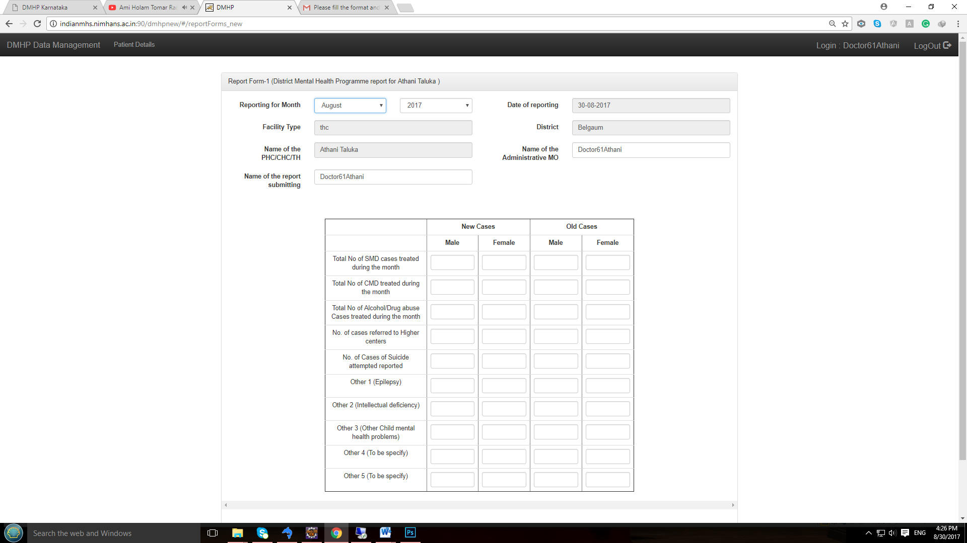

1. Enter data with respect to old and new cases gender wise from the Taluka summary report already prepared.

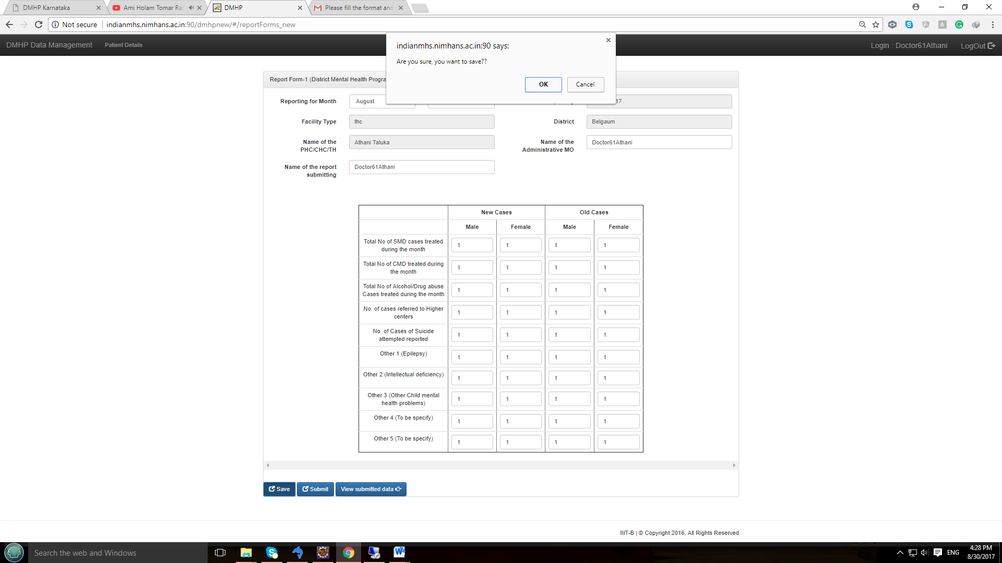

1. After completing entry for the month, check the numbers entered and then save. After clicking on “***Save***”, there will be a popup alert.



1. Click OK. You can come back, edit data and save again. Even if one or more cells are empty, it would save. After saving information you will get alert message like “***Form Saved successfully***”

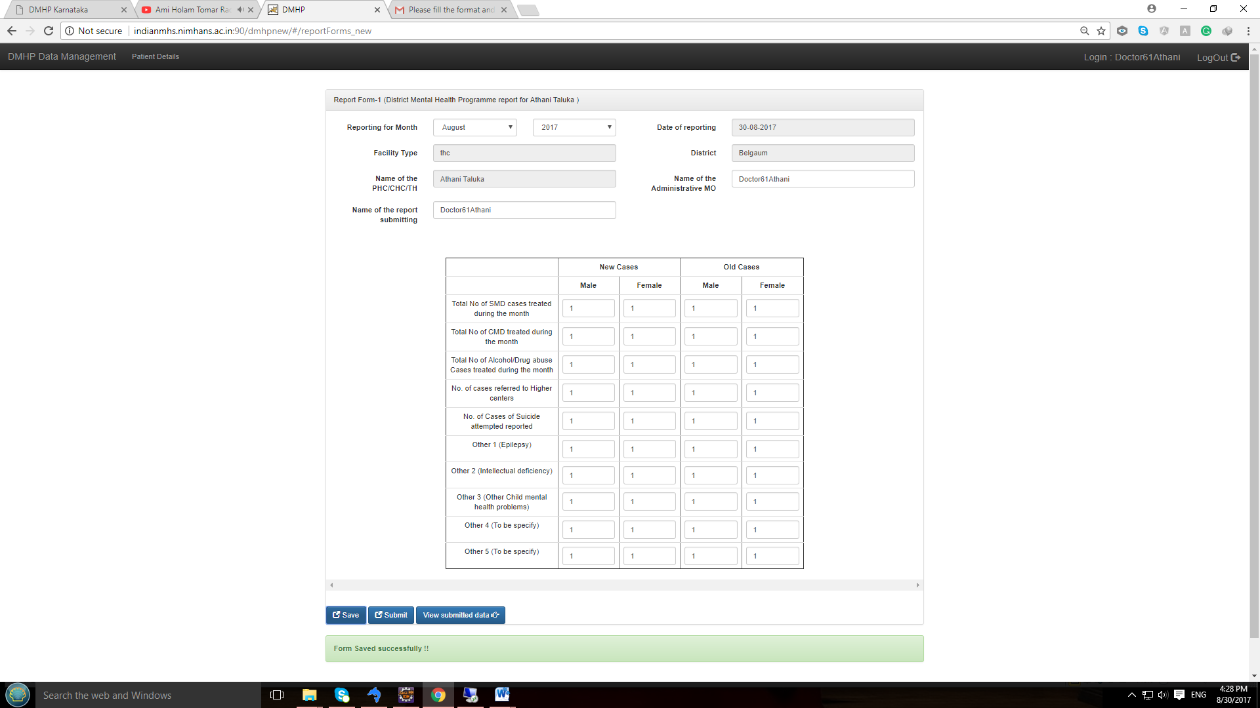

1. You can view the saved data by clicking “***View Data***”

* If data **not saved** then you will see the page like ,is it shown below and status shows as “**NOT SUBMMITED**”

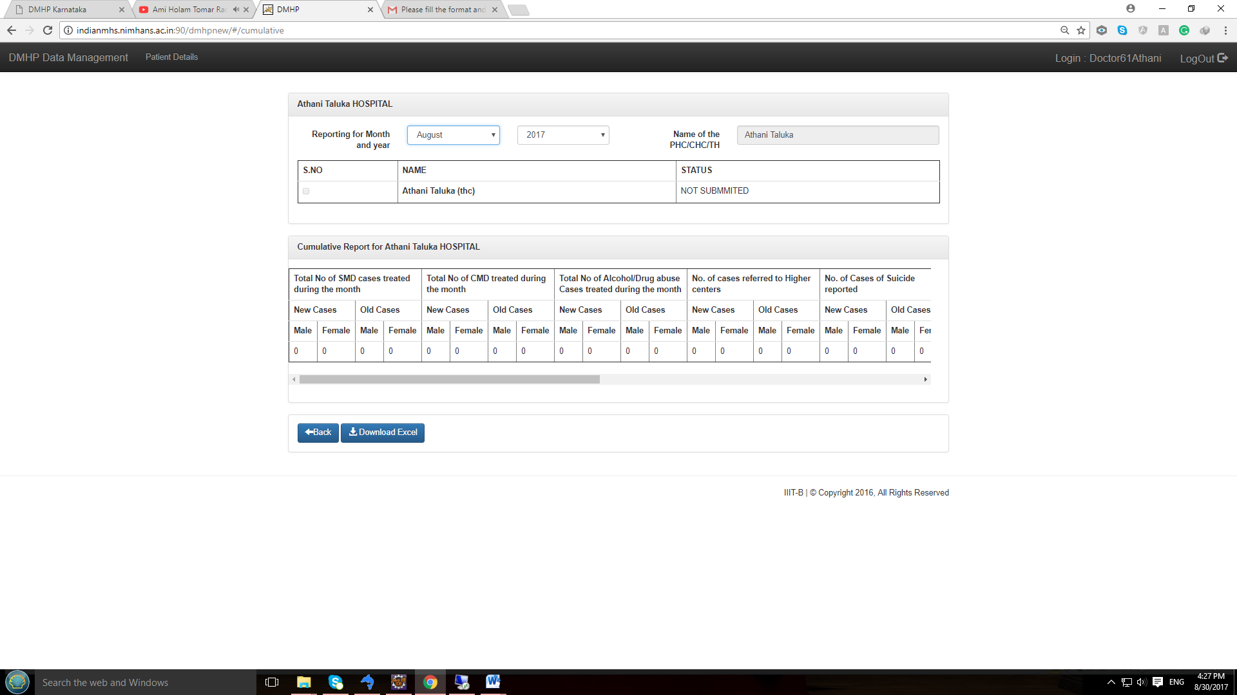

* If data is **saved but not submitted** then status changes to “**SAVED**.
* Even after the data is data saved you will not see the data in the table below till you submit the data.

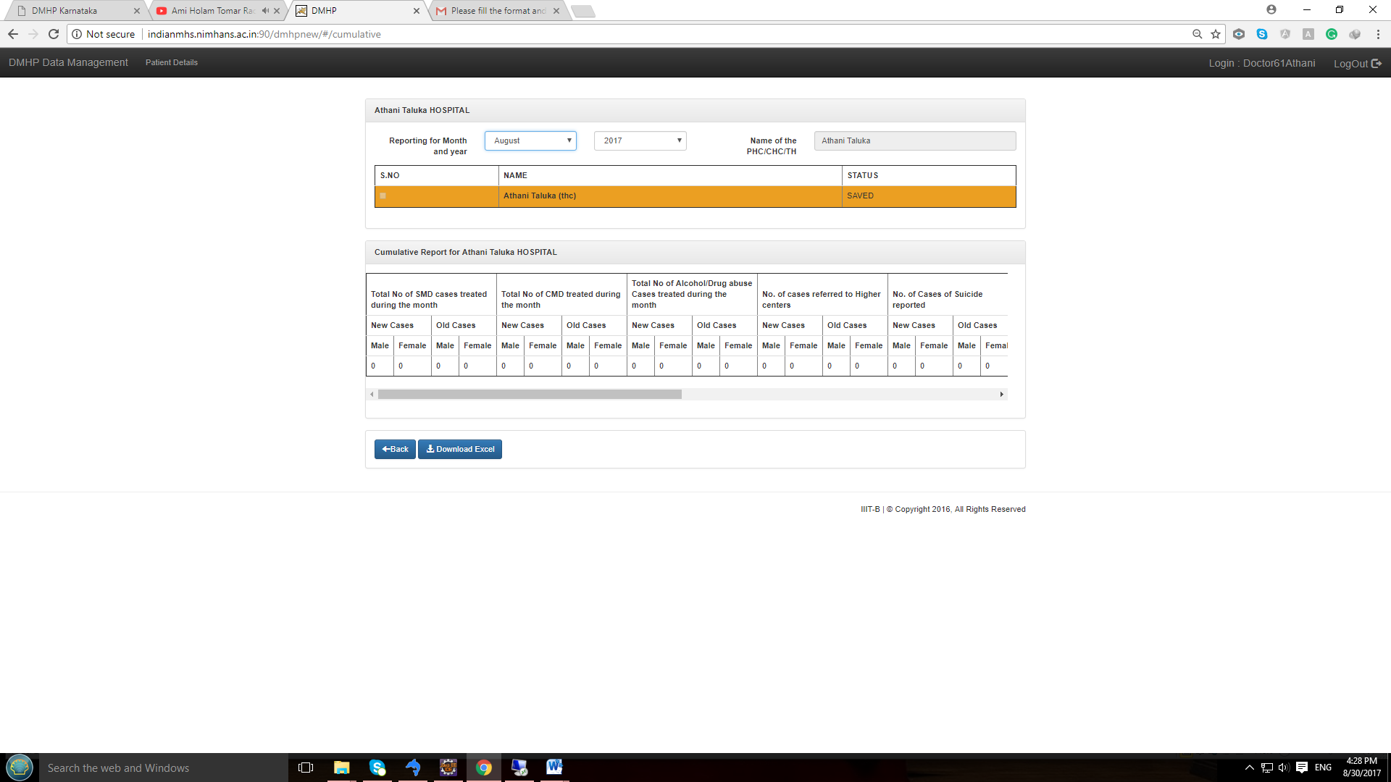

* If data is **submitted** then status changes to “**PENDING**”, it means district level user is reviewing submitted data

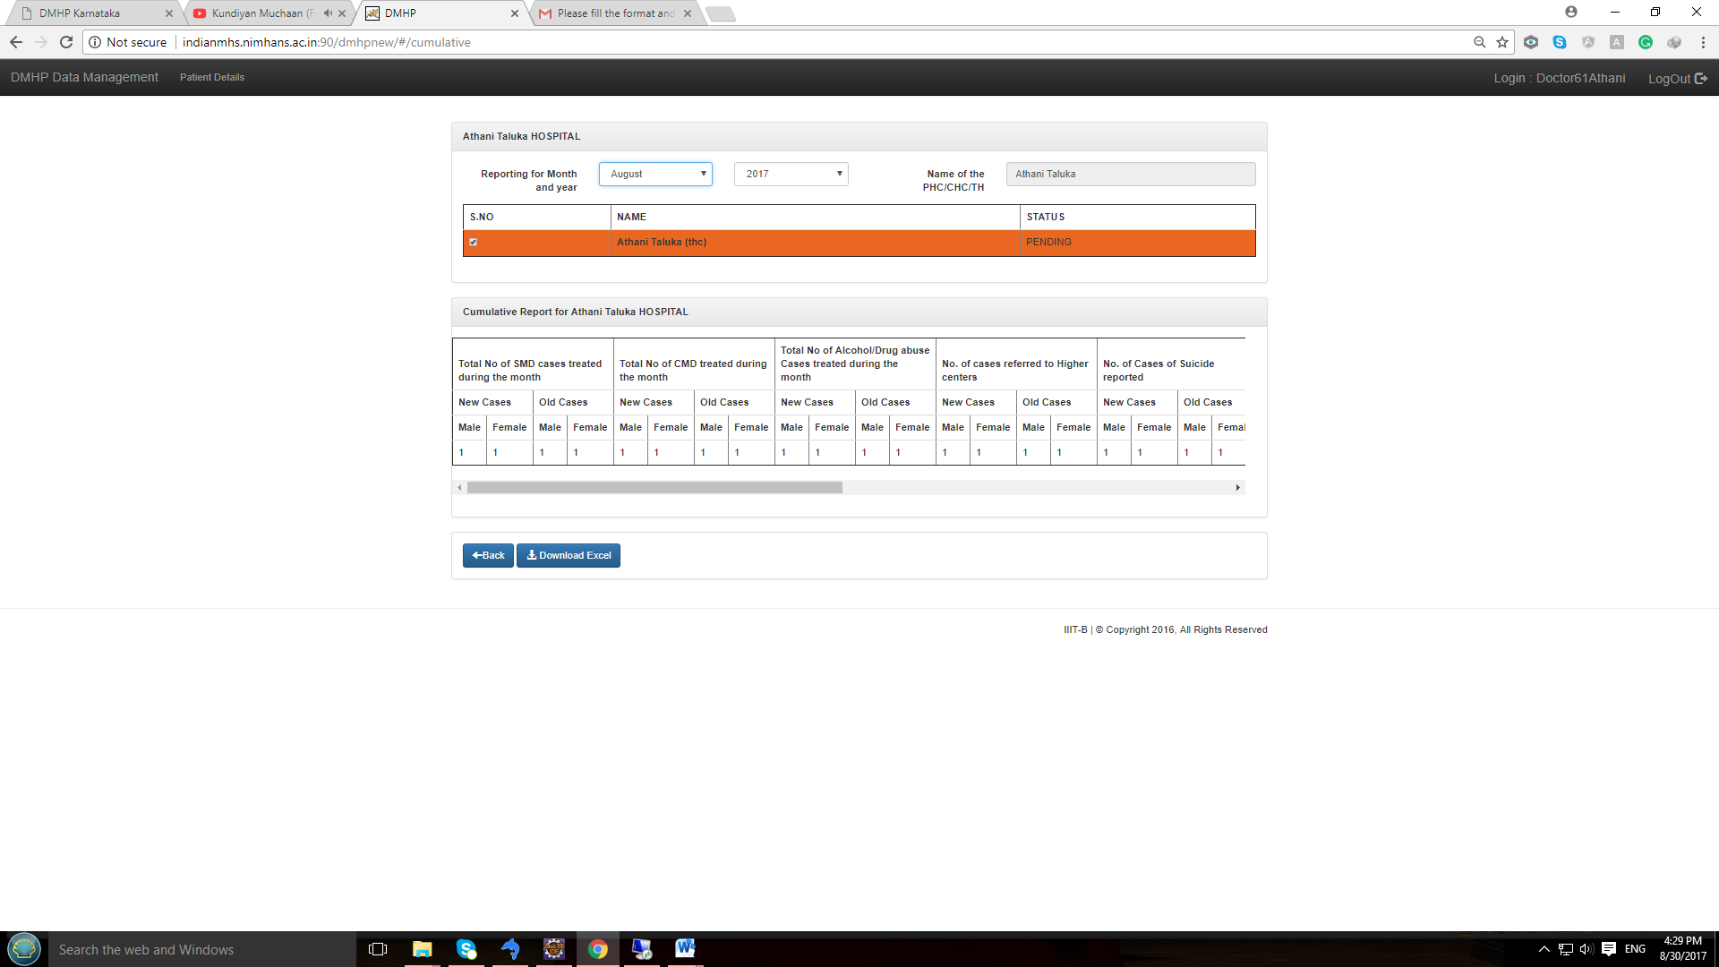

***Review of the submitted data by district level user***

* The District user after review can “**REJECT”** the submitted data. In that case at Taluka level status changes to “**REJECT**”

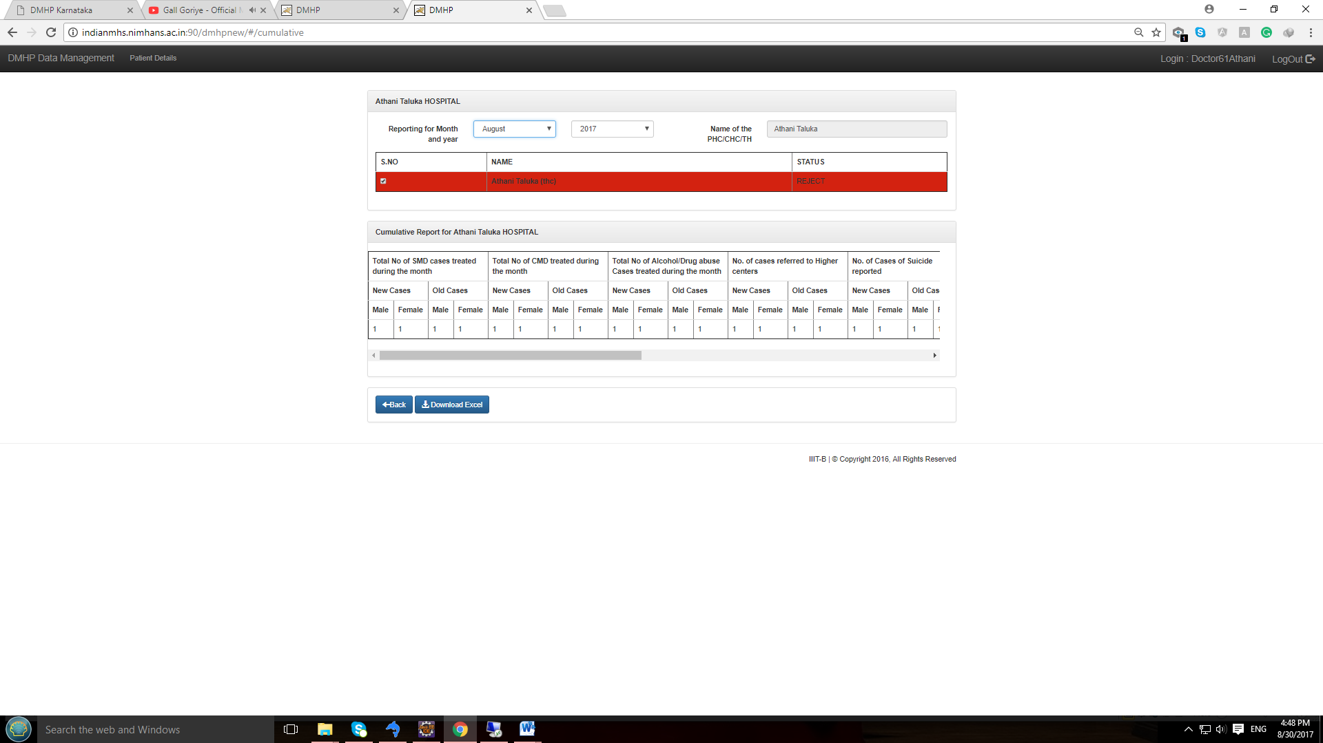

***Note****: In case data is* ***rejected*** *at district level then data re-entry option is enabled for that respective Month.*

* If the District user is satisfied with the submitted data, then user will **APPROVE** the data at district level when the status changes to “**APPROVED**”

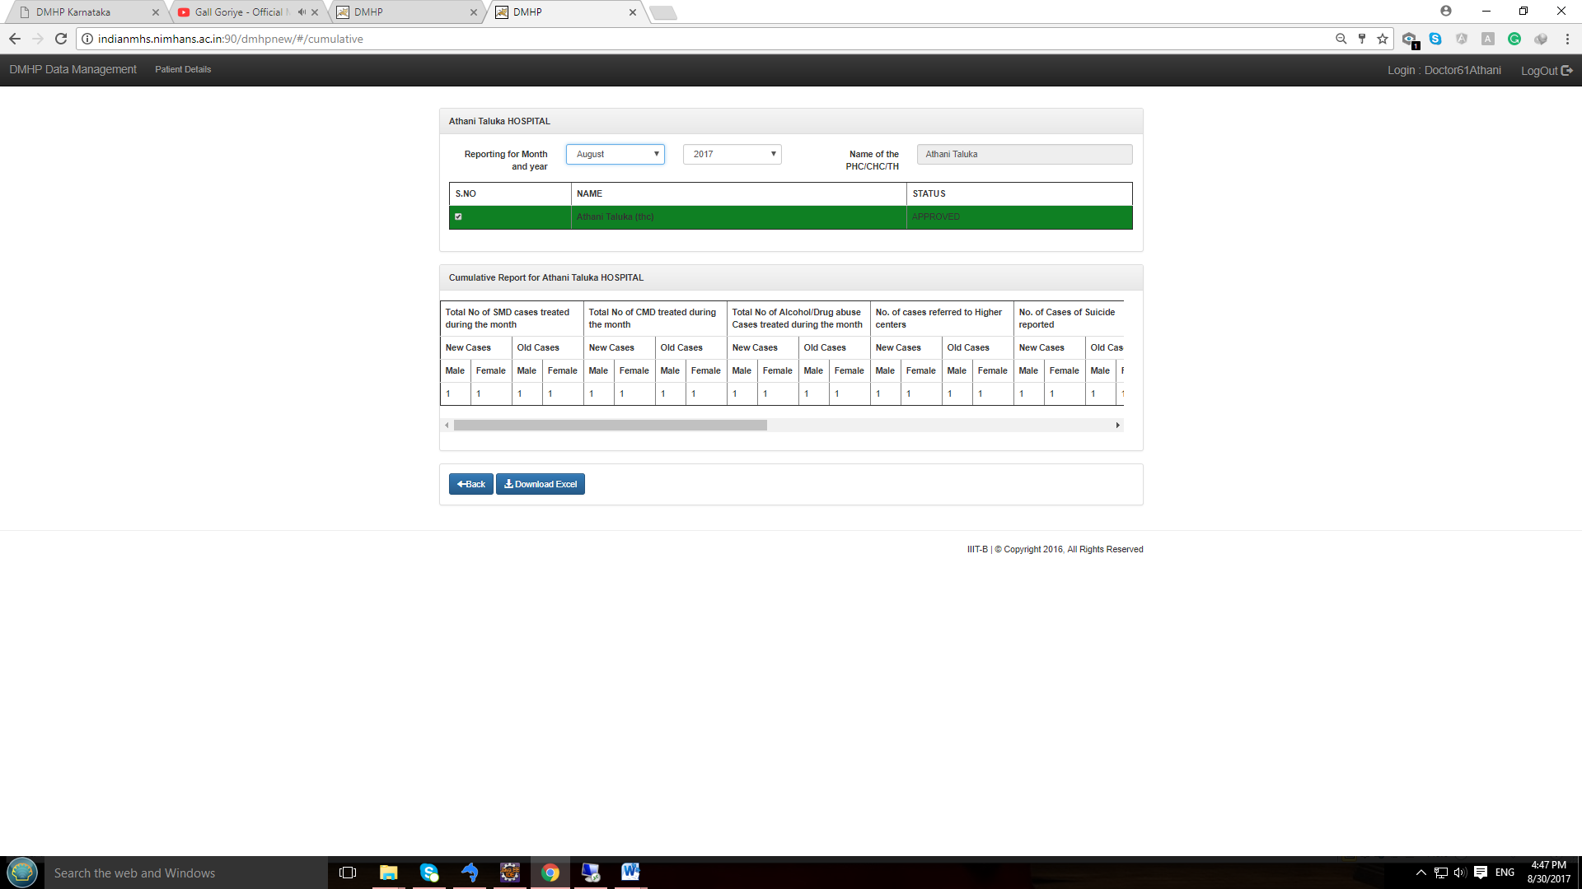

**C] District Psychiatrist Login :**

* ***For Login follow step 1 & step 2***

This login is provided to capture Monochaitanya program and Outreach activity data within the respective Taluka. Once the user logs in, the following page will appear. It is similar to THC level data entry. Select the name of Taluka & Date of visit to the respective THC for Manochaitanya program.

1. After logging in, based on Login credentials, the Facility type, District and Name of the PHC / CHC and Taluka will get populated automatically and this is by default.
2. Note that the date of reporting will be by default the Server date, month and year
3. Edit / Modify “***Name of the Administrative MO***” and “***Name of the report submitting official***” and select Taluka & date of visits of Manochaitanya program respectively

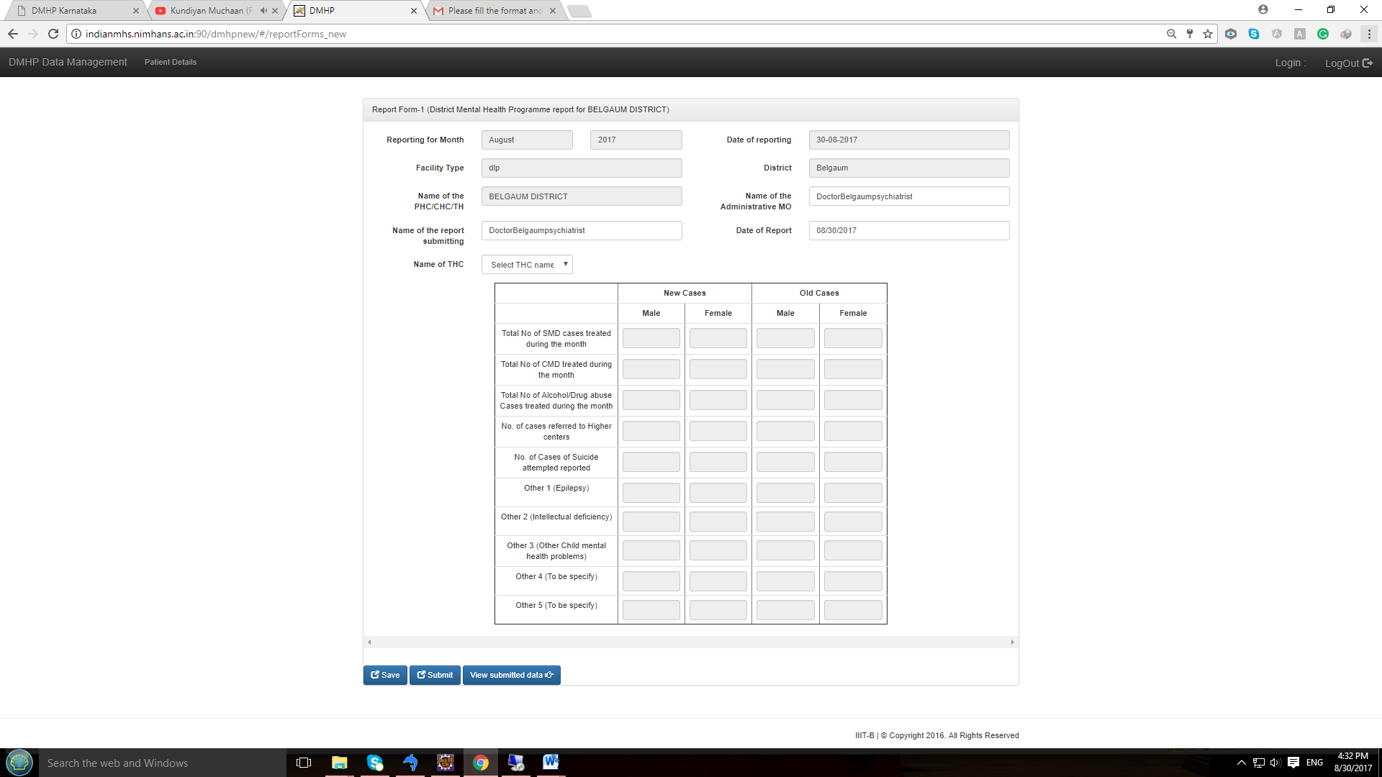

1. Enter data with respect to old and new cases gender wise from the Manochaitanya summary report already prepared.



1. After completing entry, check the numbers entered and then save. After clicking on “***Save***”, there will be a popup alert.

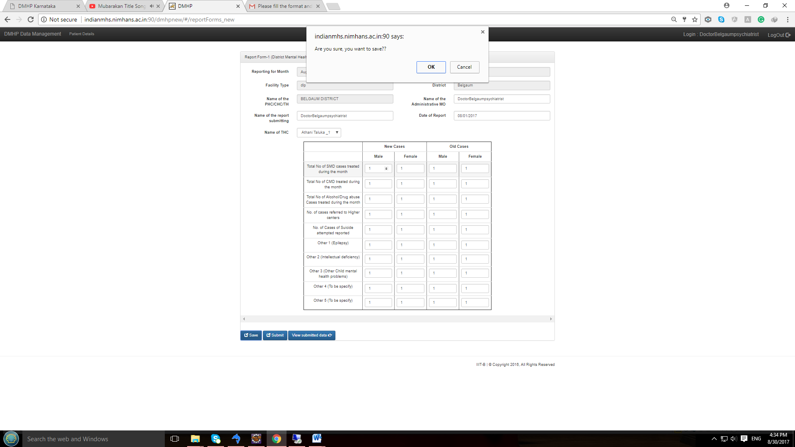

1. Click OK. You can come back, edit data and save again. Even if one or more cells are empty, it would save. After saving information you will get alert message like : “***Form Saved successfully***”



1. You can view the saved data by clicking “***View Data***”

* If data **not saved** then you see the page like below and status shows as “**NOT SUBMMITED**” and all the Taluka list appers with information as empty.

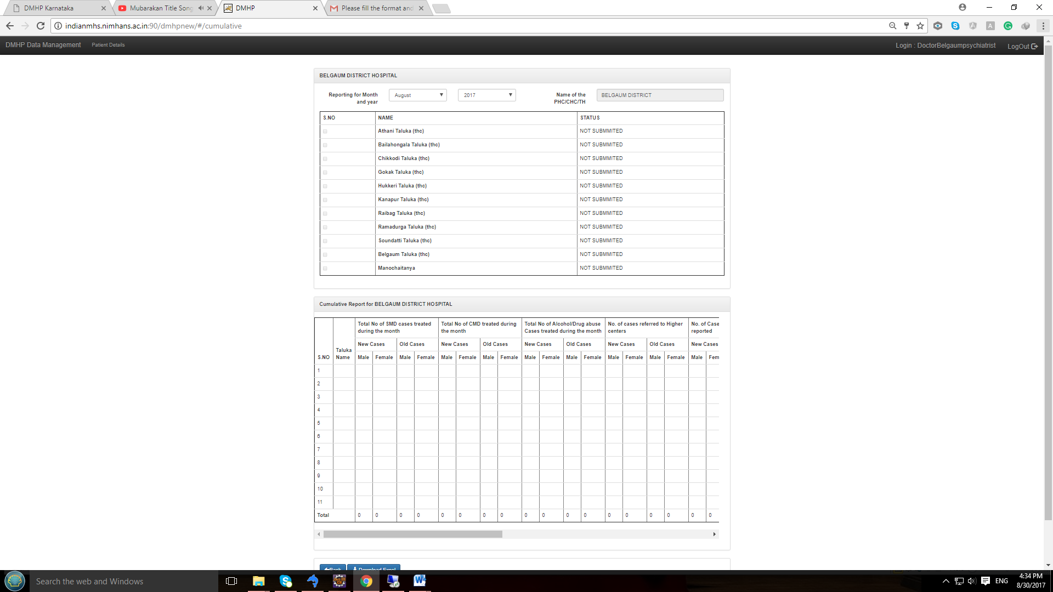

* If data is **saved** but not submitted then status changes to “**SAVED**”. If data saved then saved data is shown in the table.

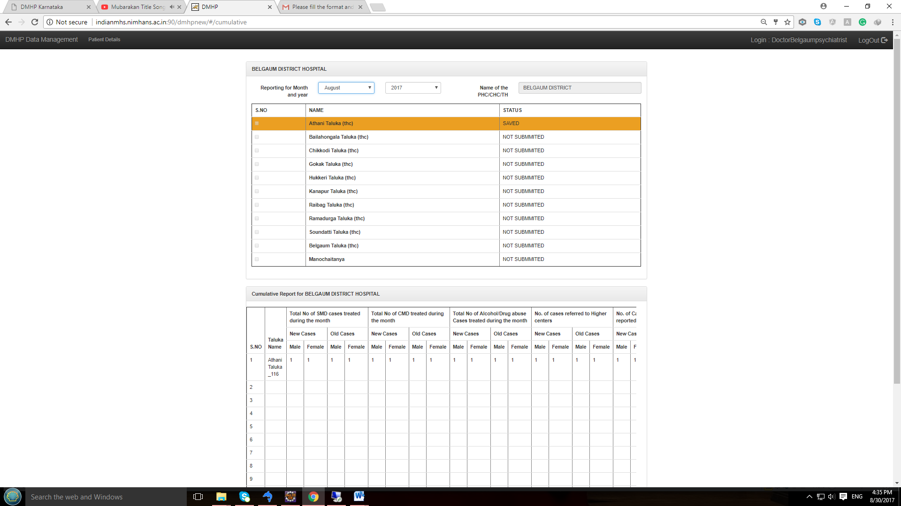

* After submitting saved data then you get alert information as “**Data Submitted Successfully**” and all fields are disabled for further data entry or correction for respective THC & Date selection

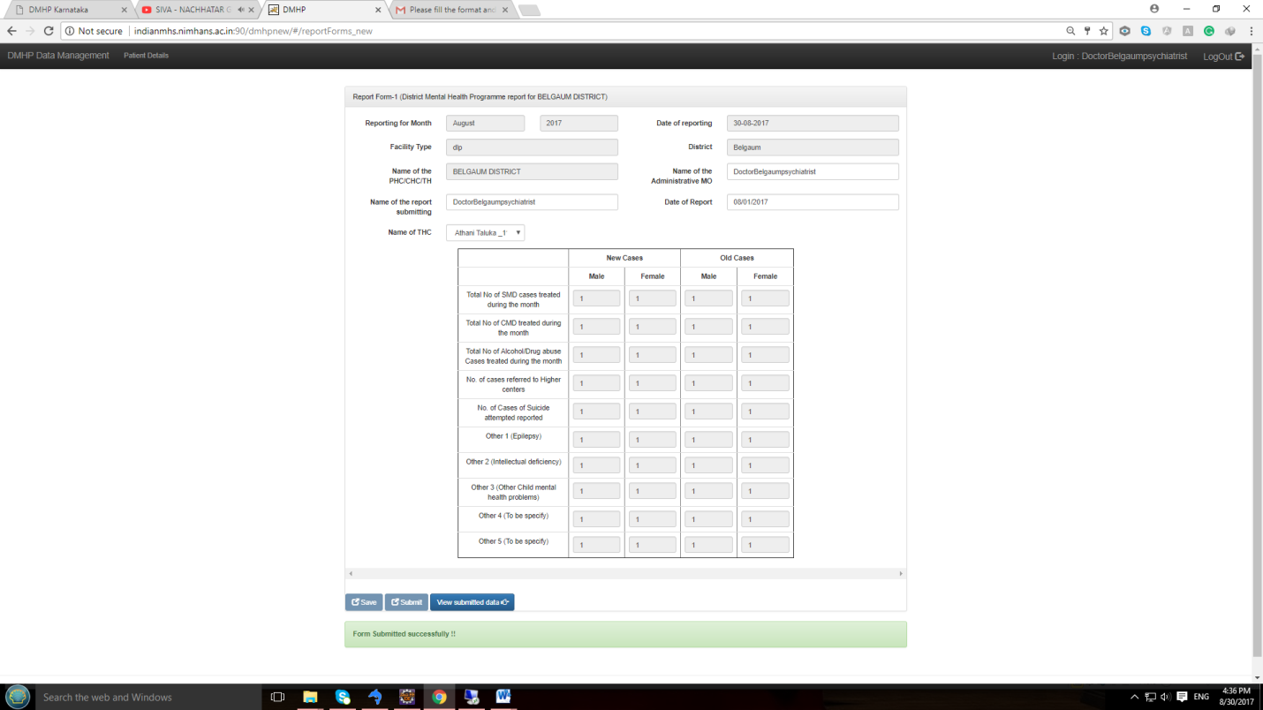

* After data is submitted then status changes to “**PENDING**”, indicating that approval is pending at district level

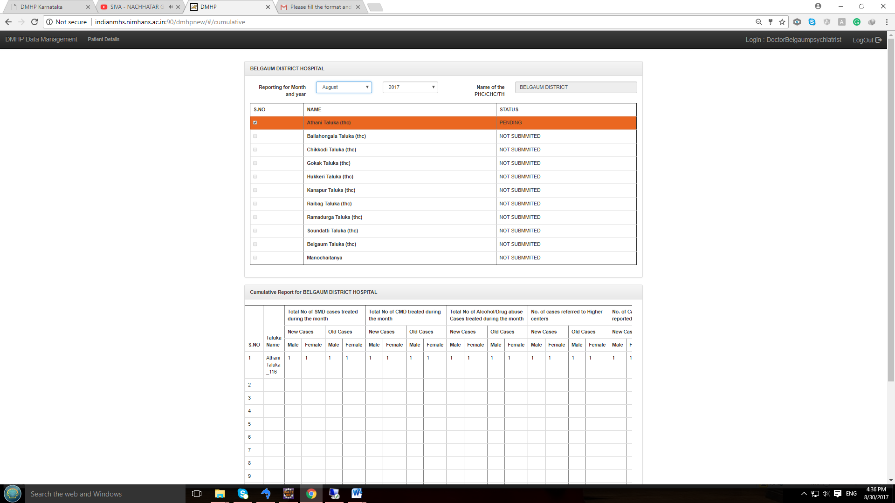

***Once the review is done at district of submitted data, district user can Approve/Reject the submitted data***

* If District user finds that the submitted data is not satisfactory, then will “**REJECT”** the submitted data, and automatically status changes to “**REJECT**”

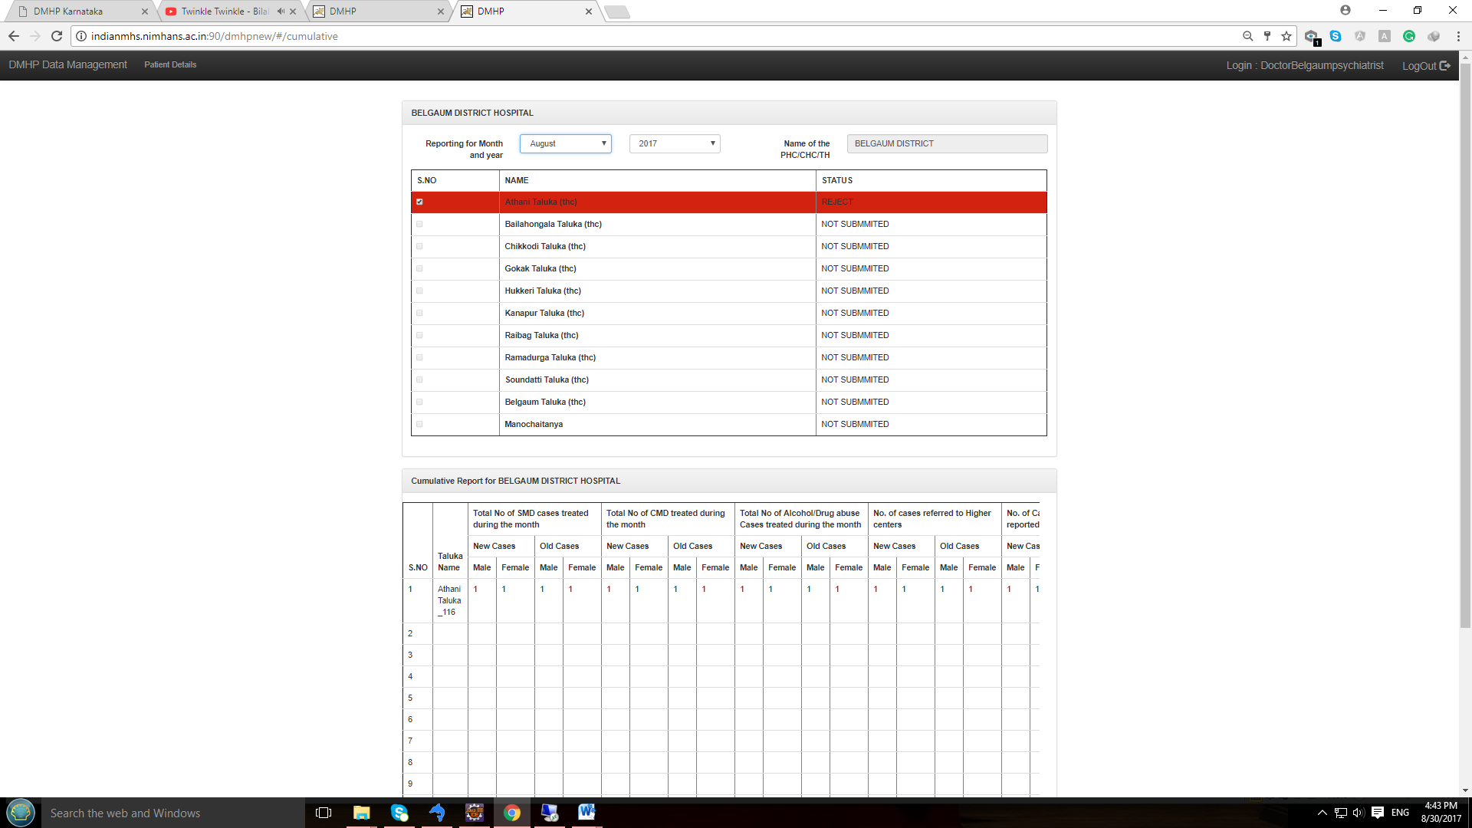

***Note*** *: In case data is rejected at district level then data re-entry option is enabled for respective THC & Date*

* If all **submitted** data is satisfied then user will **APPROVE** the data at district level then status automatically changes to “**APPROVED**”

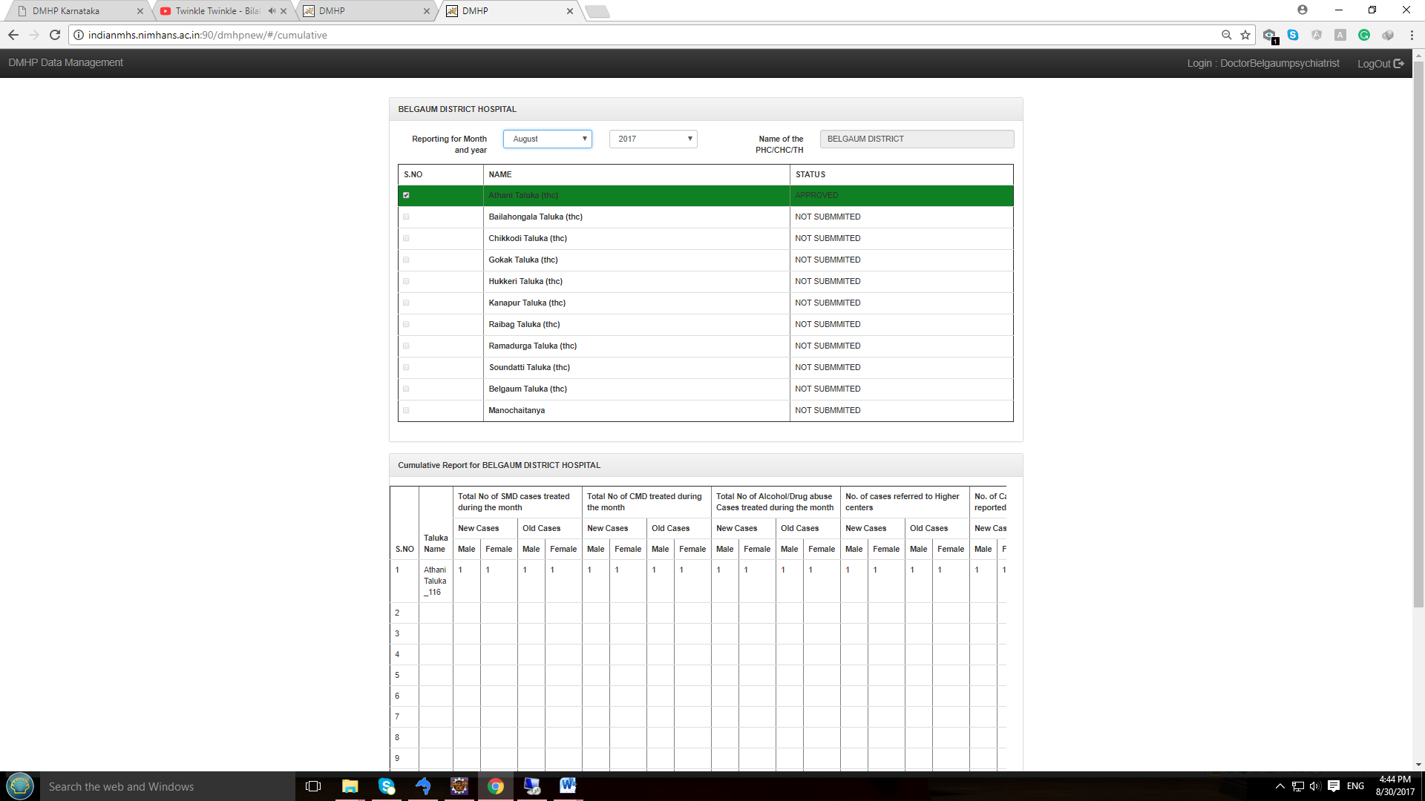

**D] District level Login:**

* ***For Login follow step 1 & step 2***

Once the user log in using respective district using user login credentials, user will see the District dashboard which indicates who all have submitted data for the month. Submitted data row will appear in Green color.

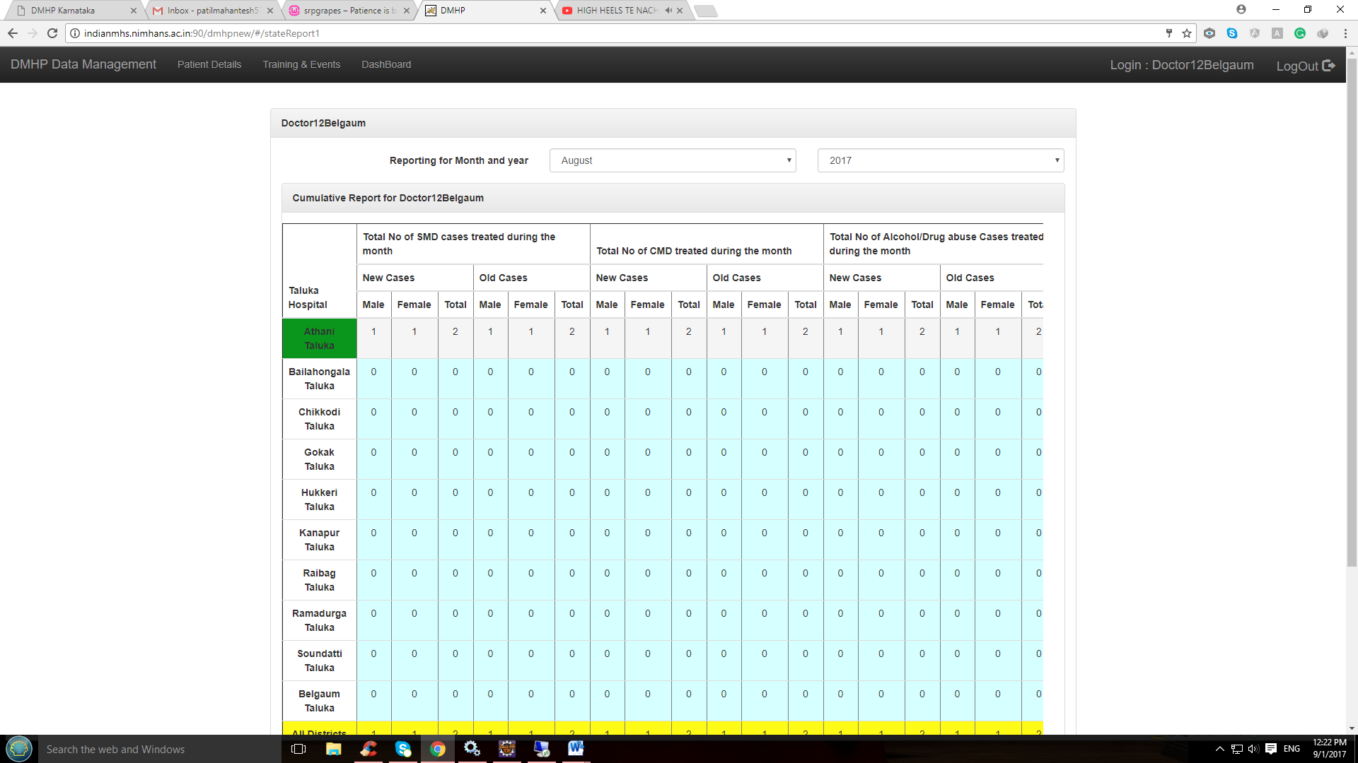

**Data entry**

1. After logging in, based on Login credentials, the Facility type, District and Name of the PHC / CHC and TH will get populated automatically and this is by default.
2. Note that the date of reporting will be by default the Server date, month and year
3. Edit / Modify “***Name of the Administrative MO***” and “***Name of the report submitting official***”

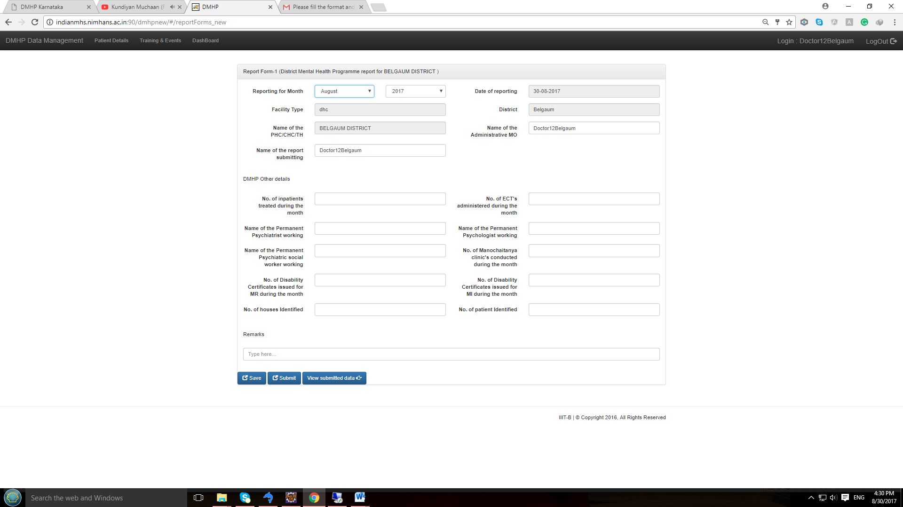

1. Enter data regarding Inpatients, ECT’s given, Certificates issues etc.



1. After completing entry for the month, check the numbers entered and then save. After clicking on “*Save*”, there will be a popup alert.

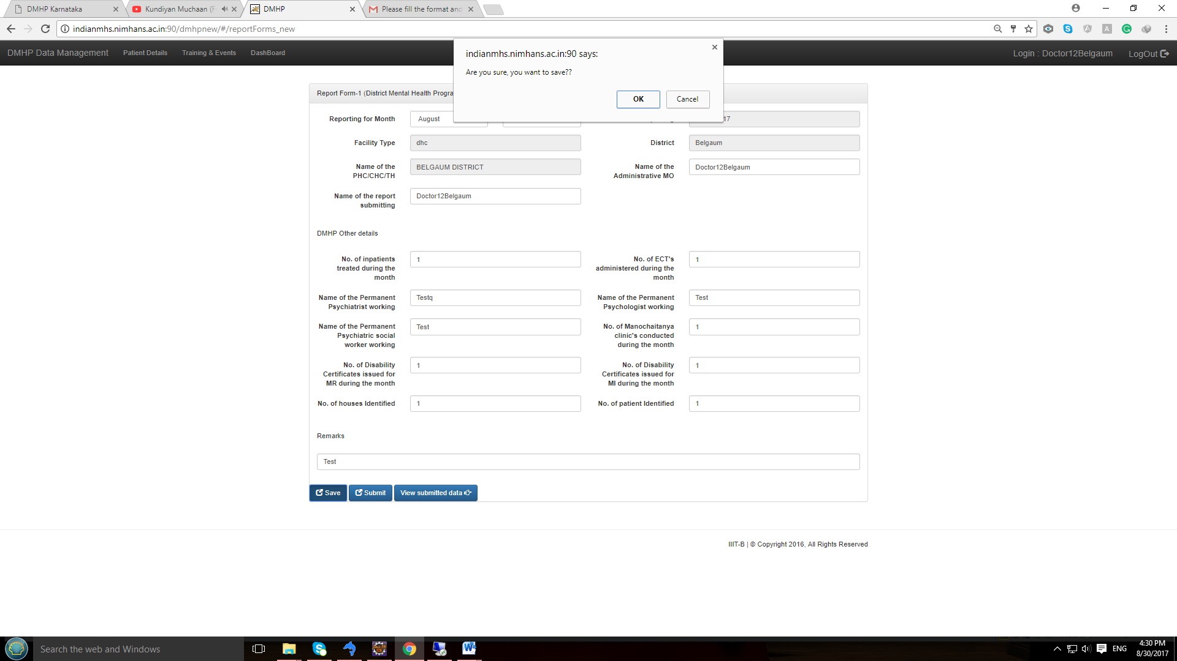

1. Click OK. You can come back, edit data and save again. Even if one or more cells are empty, it would save. After saving information you will get alert message like : “***Form Saved successfully***”



1. You can view the saved data by clicking “***View Data***”

* If data **not saved** then you see the page like below and status shows as “**NOT SUBMMITED**” Taluka data & manochaitnya submitted data which are submitted can be seen.

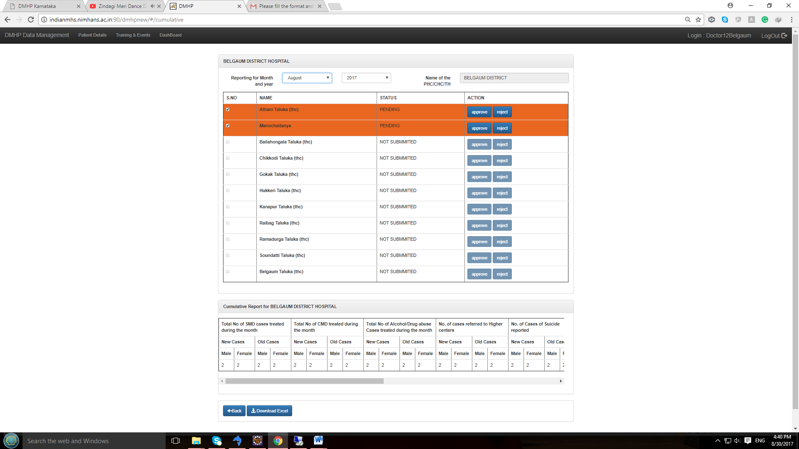

* If data has been **saved** at Sub-district level but not yet submitted then status will be seen as “**SAVED**”,

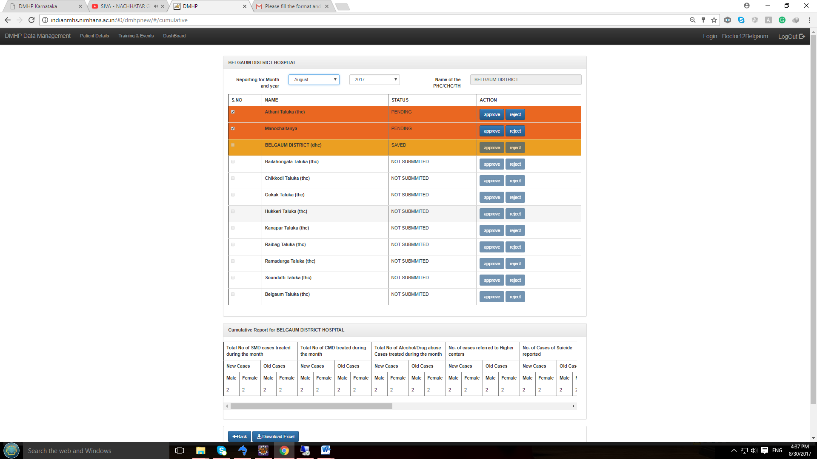

1. After submitting saved data then you get alert information as “**Data Submitted Successfully**”. After submission, all fields are disabled for further data entry correction for month and “**save and submit**” buttons are disabled.

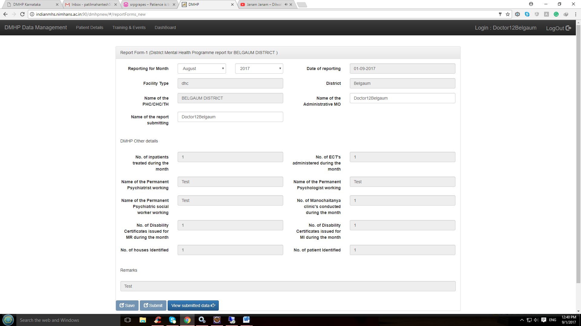

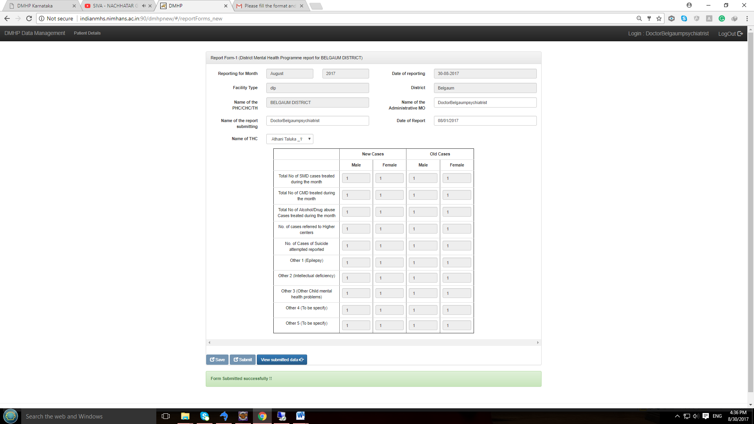

1. After data is submitted then status changes to “**PENDING**”, it means district level user need to review the submit data

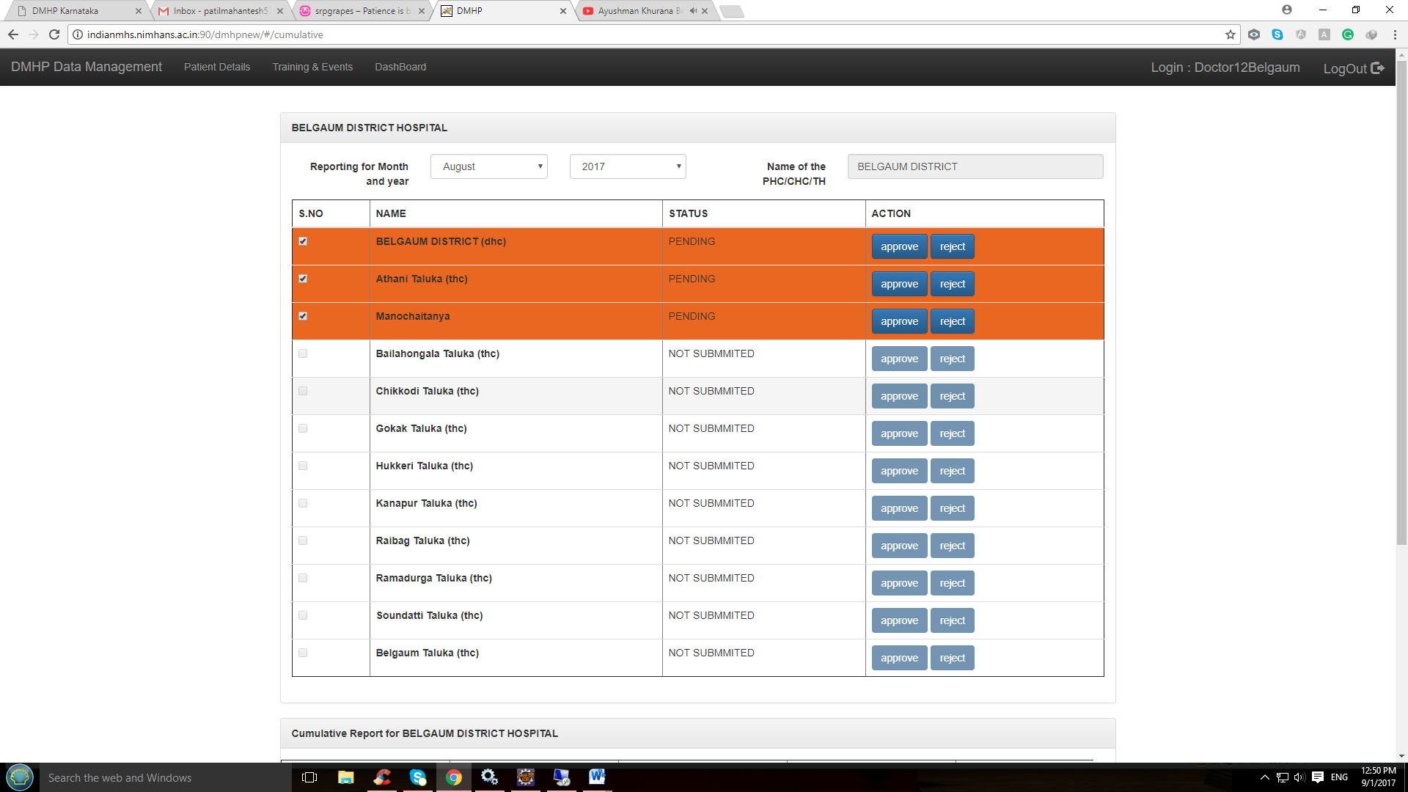

**District login Approve & reject:**

* *If Approved status changes to “APPROVED”*

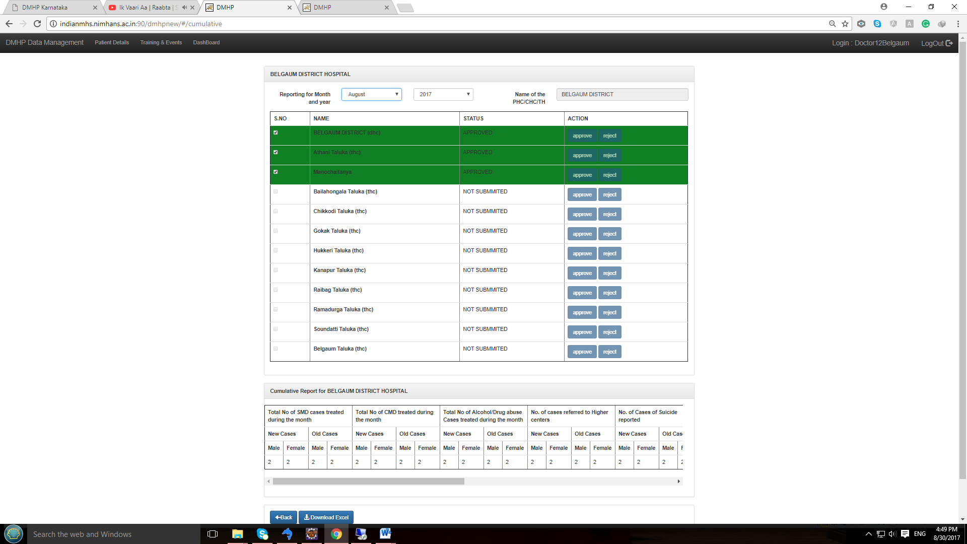

* *If Rejected Status changes to “REJECT”*

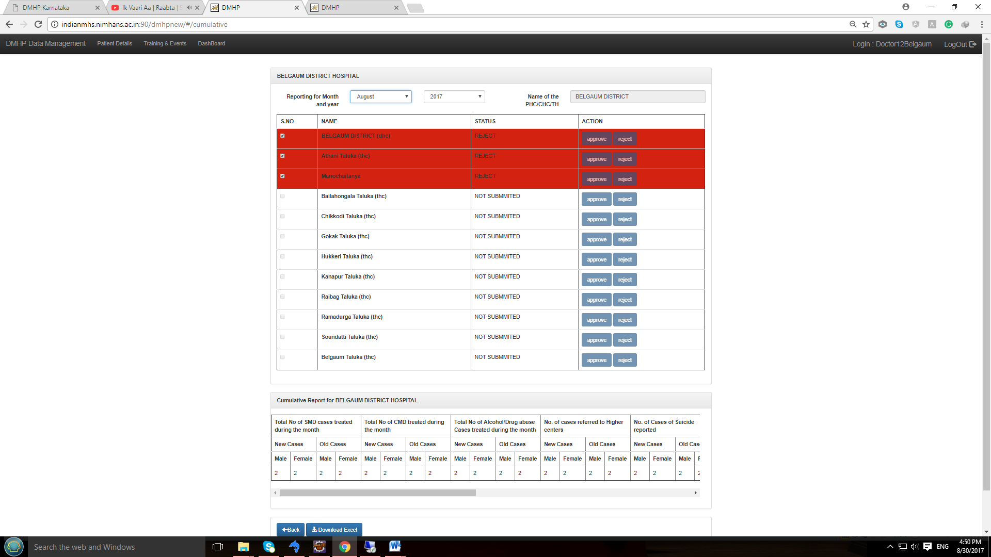

***Note: Rejected THC & Manochaitanya data can be edited and resent***

**E] Training & Events at district level Login :**

* **Data entry**

Data pertaining to training, awareness programs , IEC, Targeted Intervention, etc., are entered using district level login

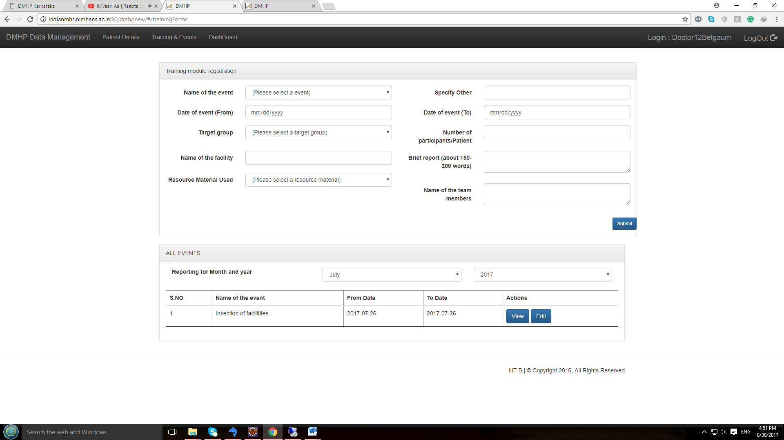

* **View Submitted data**

View Submitted Training &event data for respective month: If you click the **view** button against the selected training & event, details from the list will show-up as follows. Please note you can view the details only.

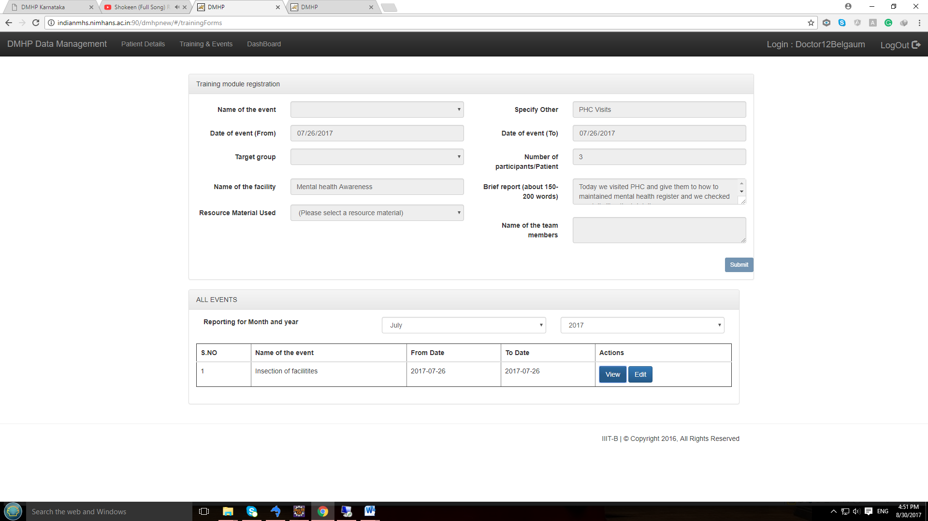

**Edit Submitted data**

Editing Training & event data for respective month: If you click the **Edit** button for selected submitted training & event details from the list, then data can be edited.

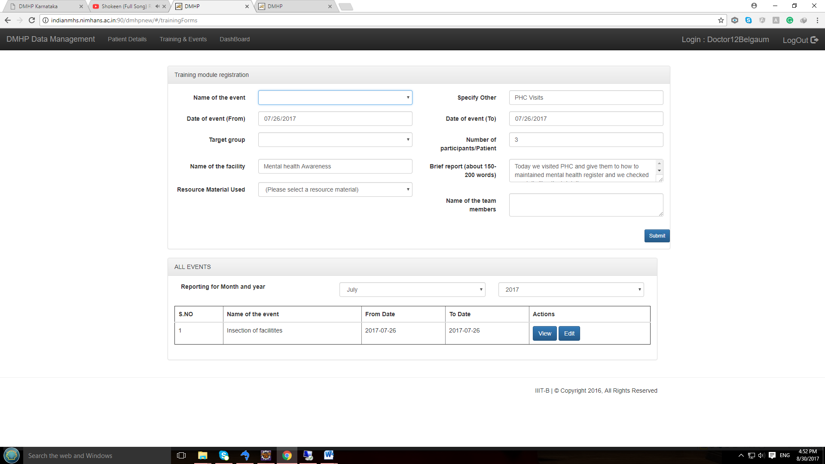

**F: State level Login:**

* Dashboard

The different reports that get generated at state level are Data reports (month-wise and cumulative) and other information cumulative

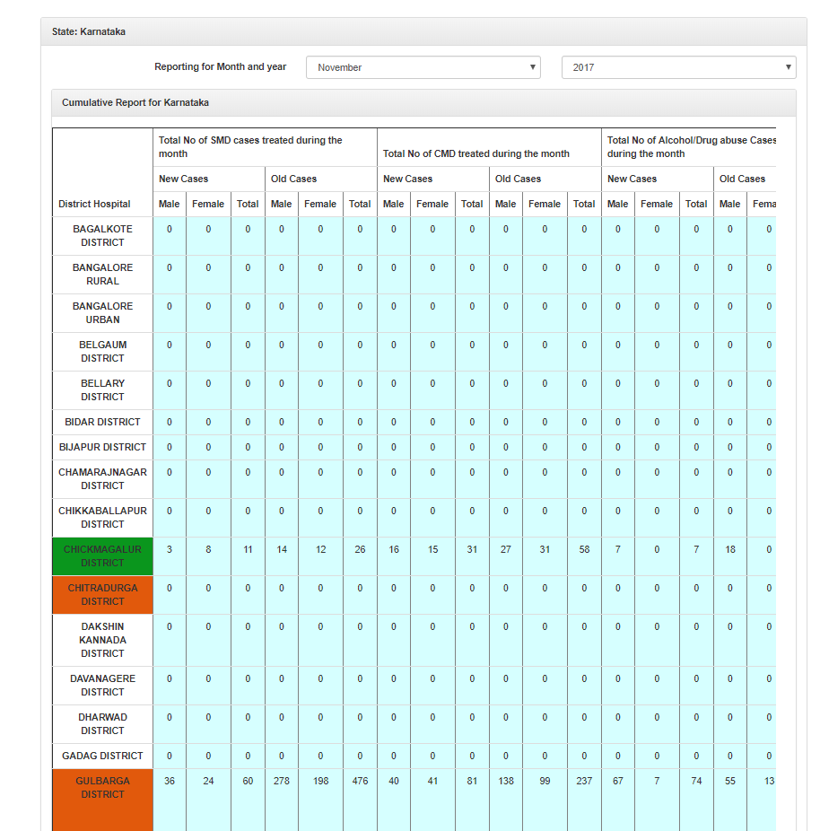

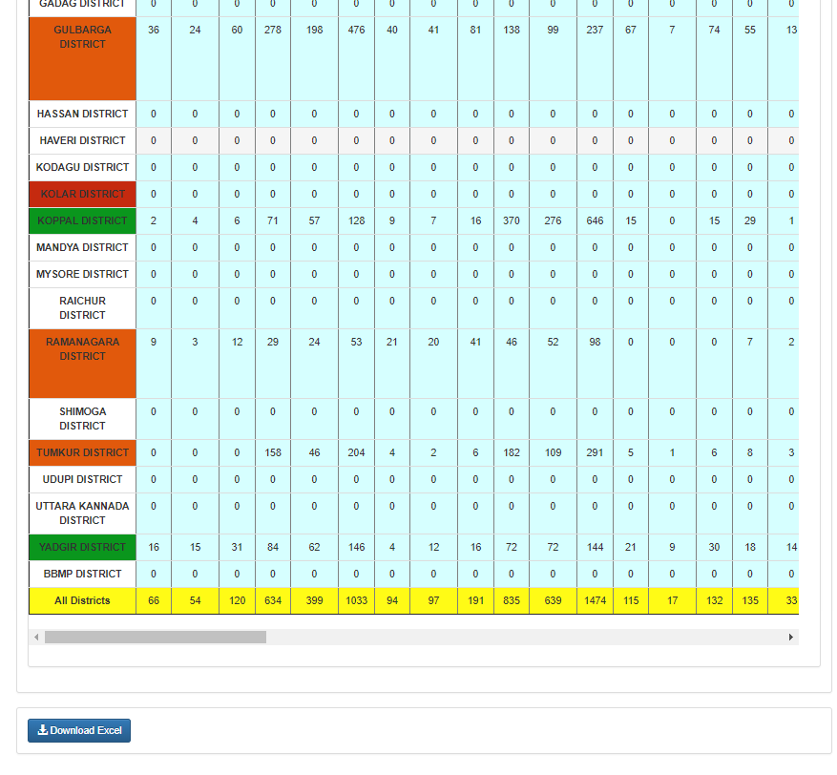

* **Monthly Data report Month wise**

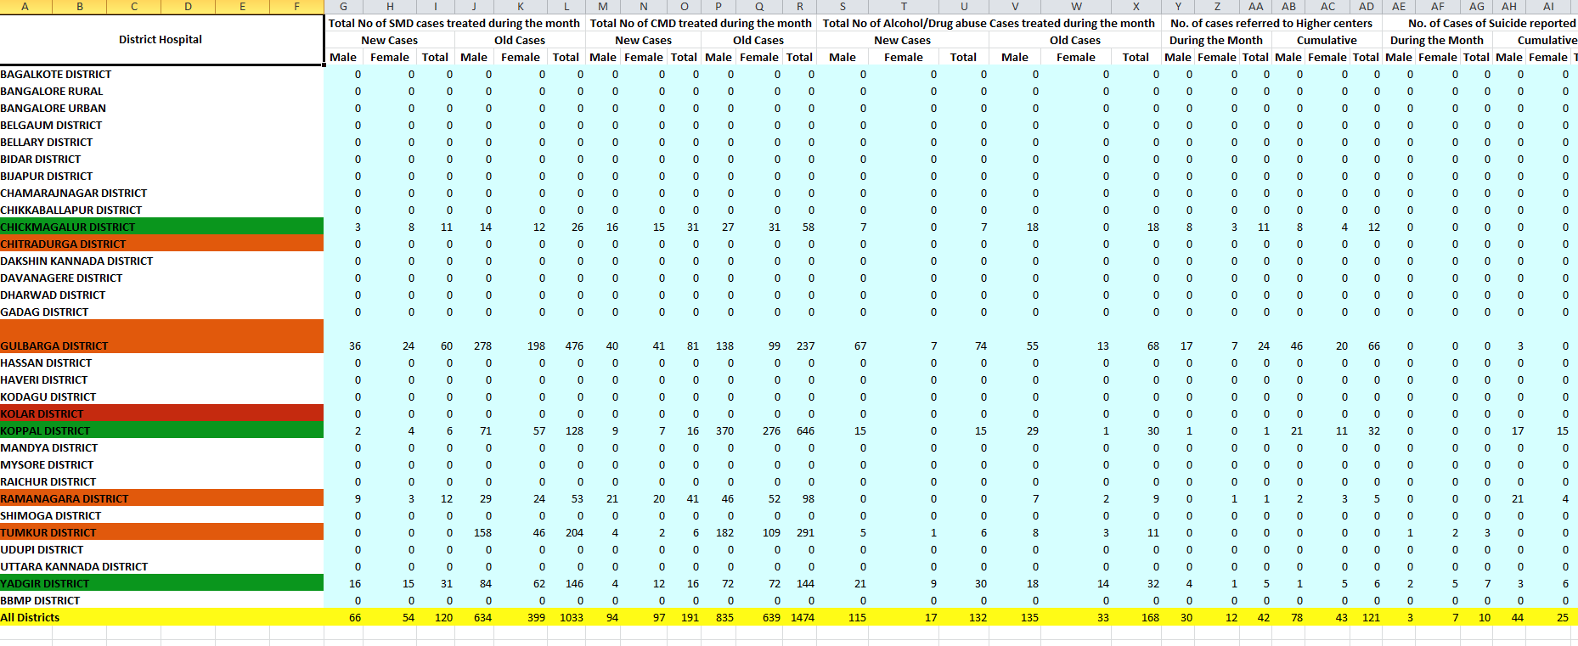

* **Monthly Data report Cumulative**

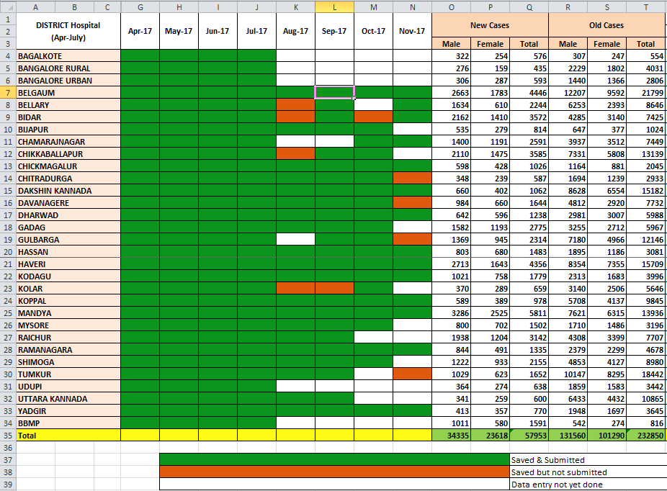

* **Patient Other data information**

